Name: | Hassan Ehab Abdelrahman
Groub: | 17

UART TX Block

Test cases simulation waveform

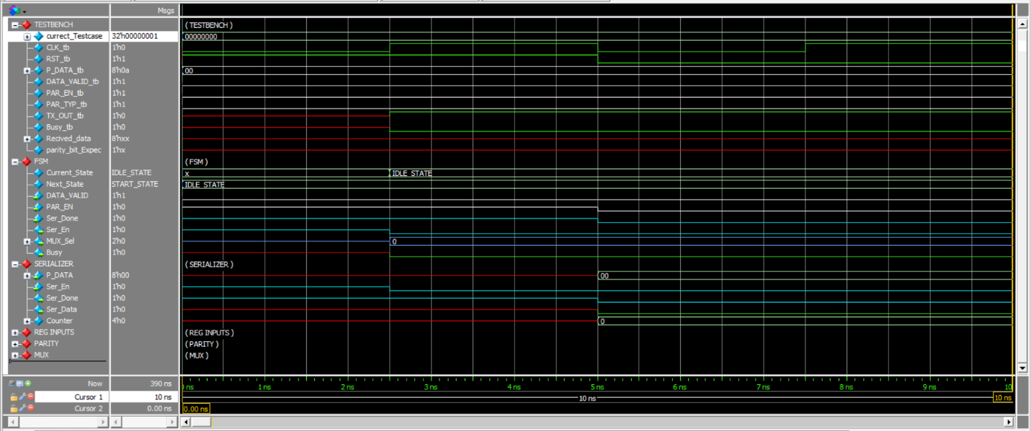
Figure 1 TESTCASE 0: Reset
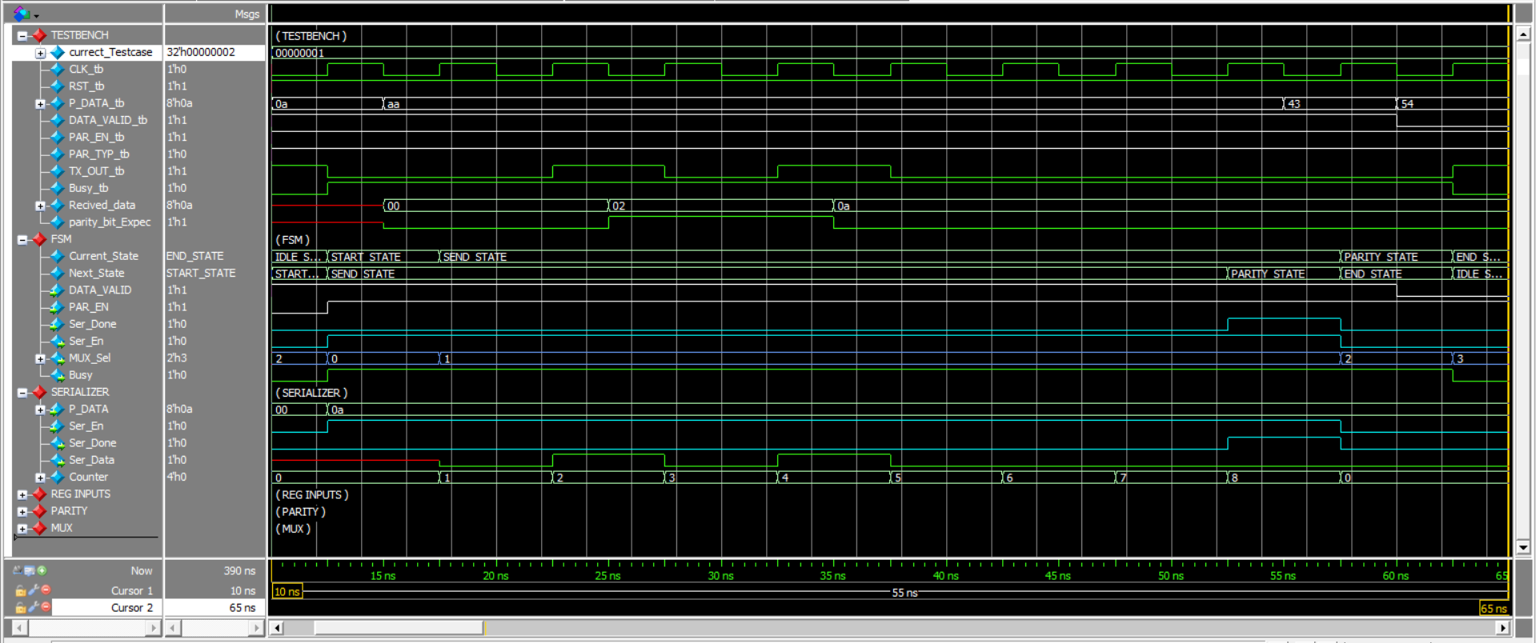
Figure 2 Testcase 1: expected to get an IDLE - START - SEND - PARITY – STOP

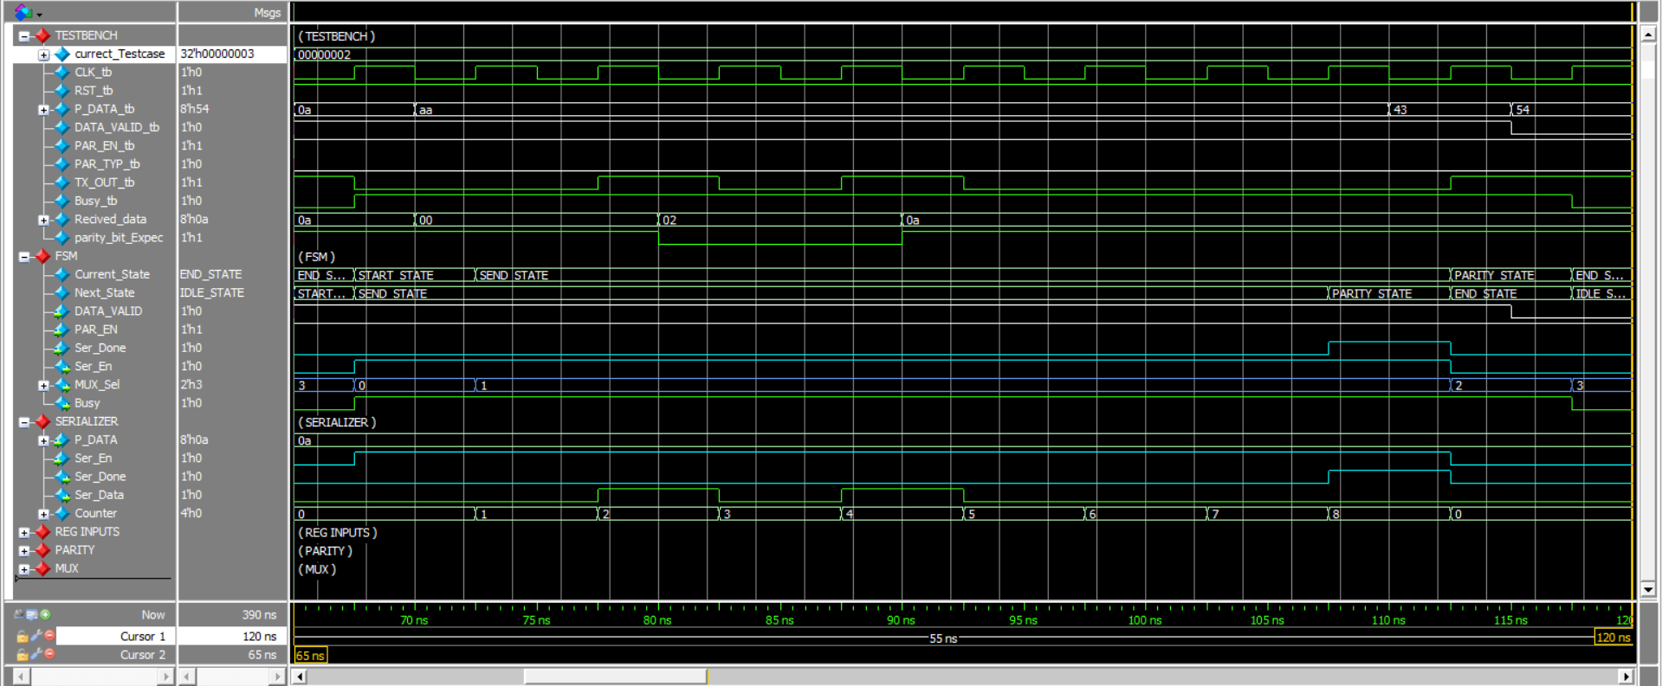
Figure 3 Testcase 2: expected to get an START - SEND - PARITY – STOP (IDLE skipped)

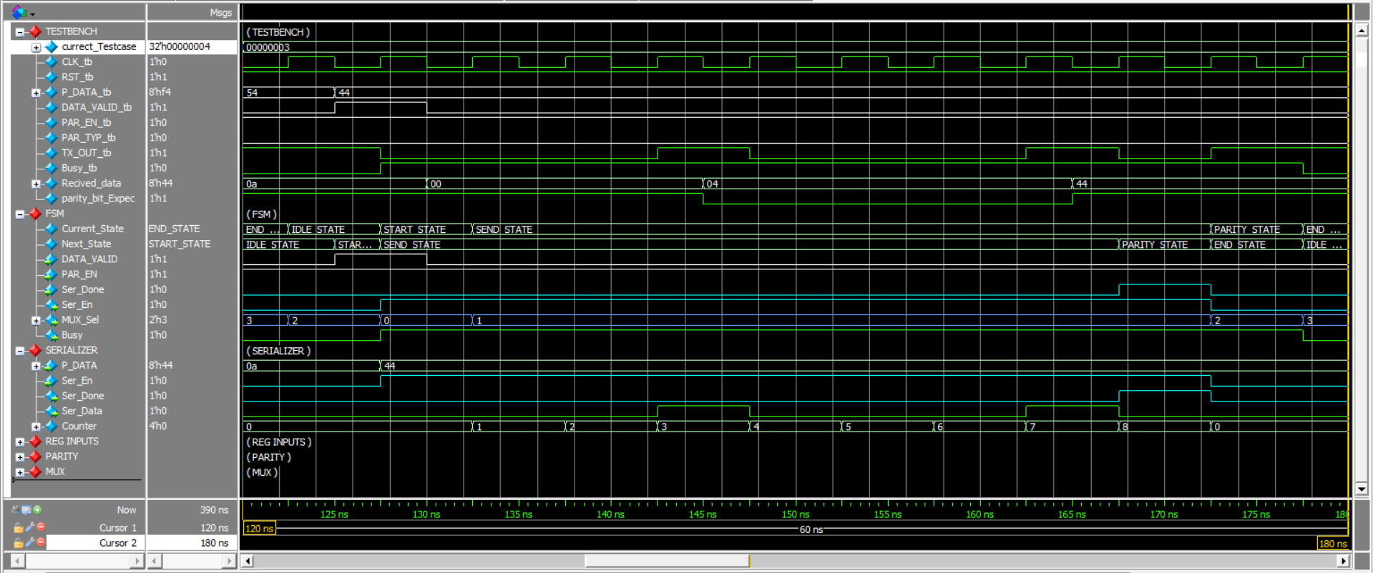
Figure 4 Testcase 3: expected to get an IDLE - START - SEND - PARITY – STOP (IDLE returned)

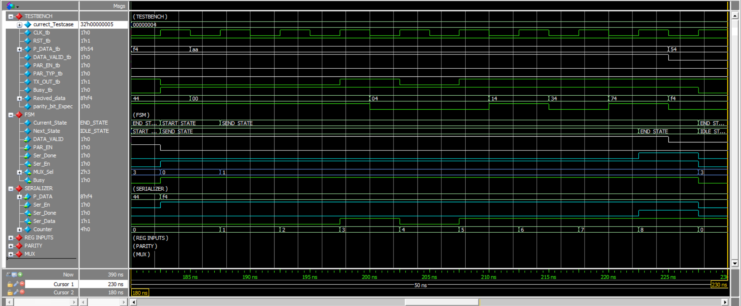
Figure 5 Testcase 4: expected to get an START - SEND – STOP (IDLE and PARITY skipped)

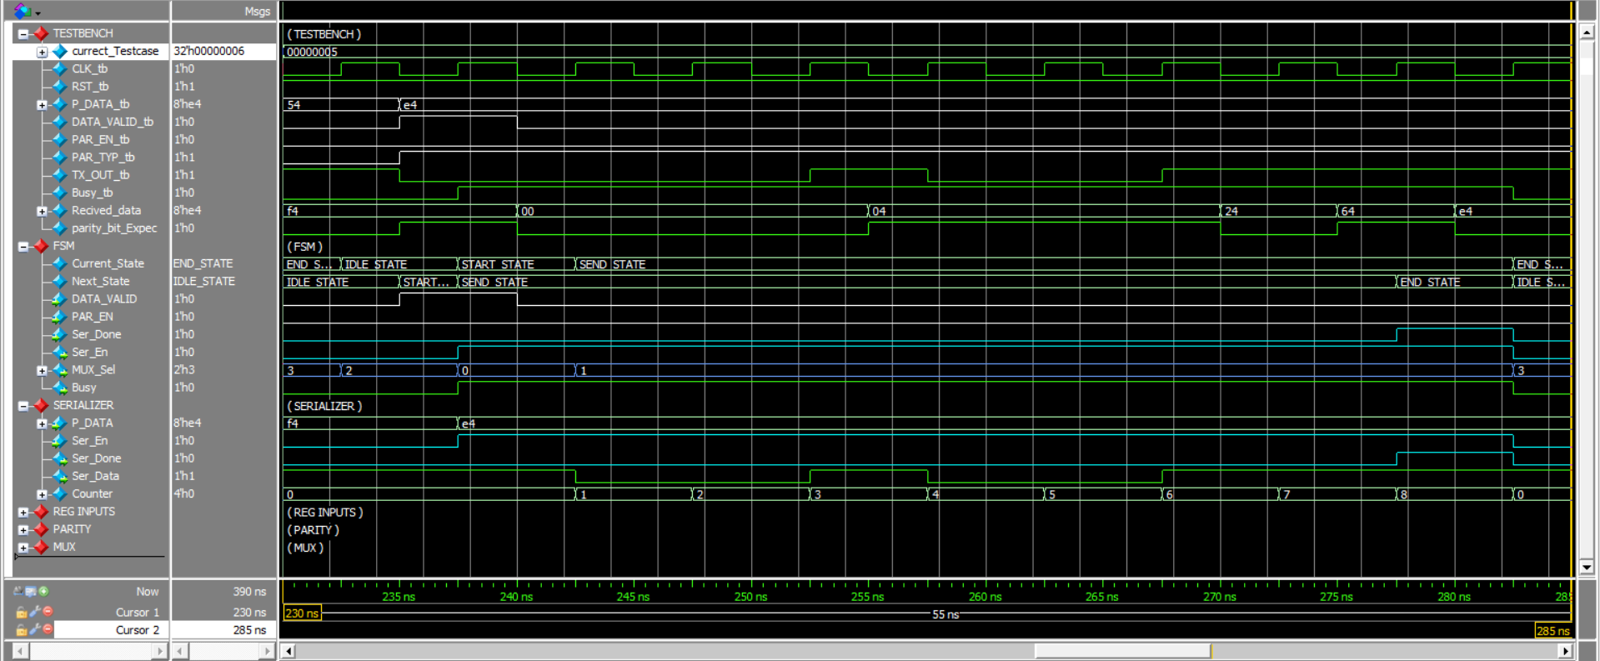
Figure 6 Testcase 5: expected to get an IDLE - START - SEND – STOP (PARITY skipped)

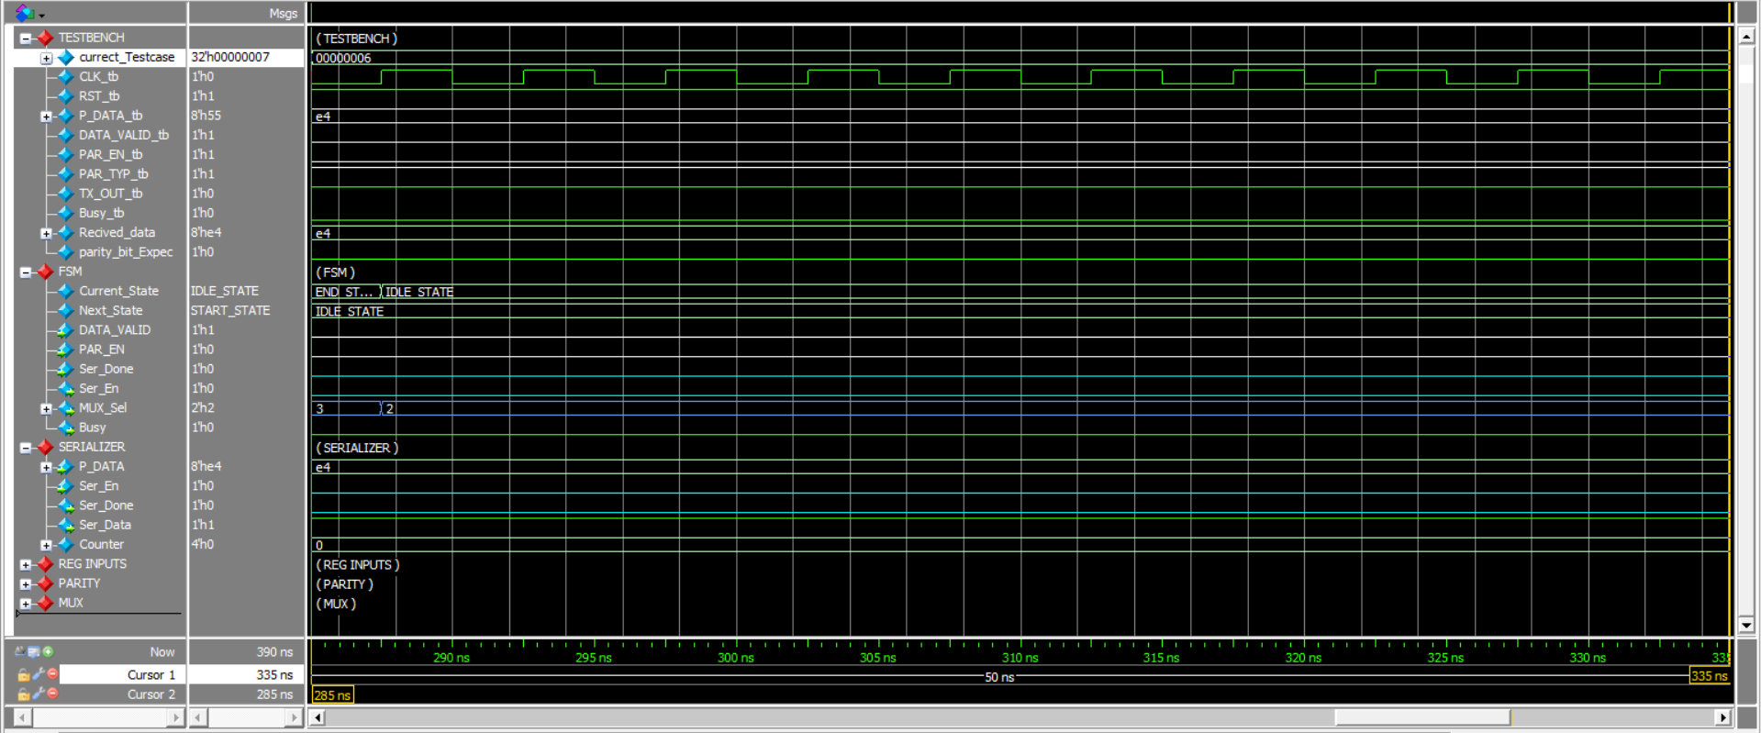
Figure 7 Testcase 6: expected to get an IDLE STATE and high TX_OUT and low Busy signal

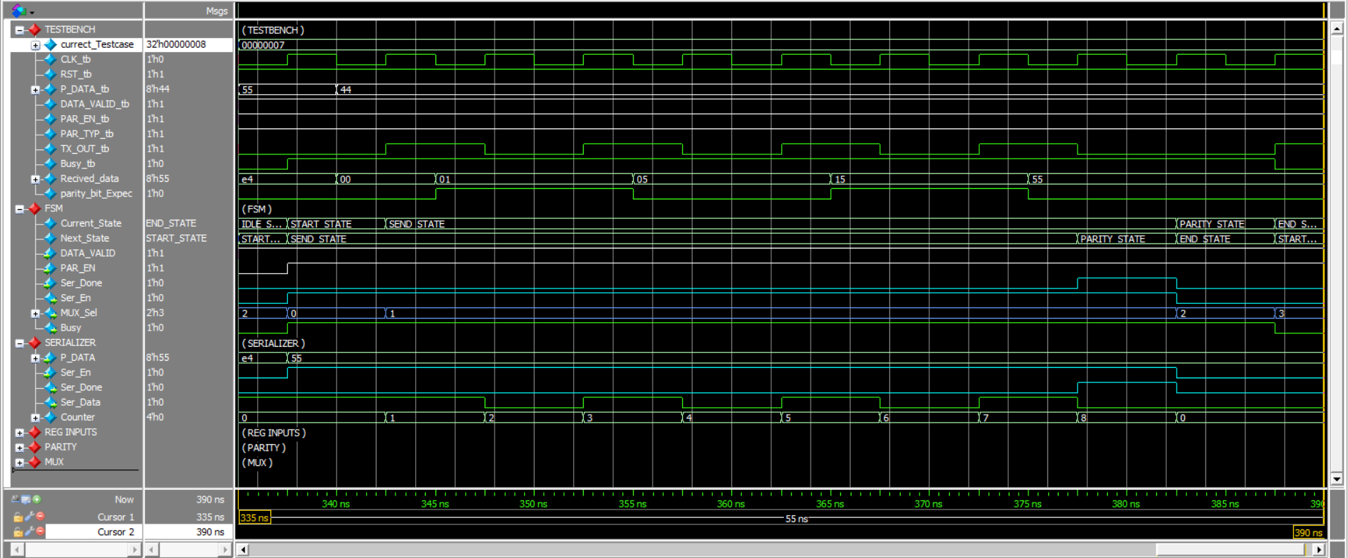
Figure 8 Testcase 7: expected to get an IDLE - START - SEND - PARITY – STOP (check the effect of always high DATA_VALID signal)

(Transcript) for Test cases
